RA7_Personalized Retail Recommendation AI Agent (AI-Driven Shopper Assistant)
Contents
1. Project Overview 1
Problem Statement 1
Goal 2
2. Intended Users 2
3. Scope Definition (Very Important for Freshers) 2
4. High-Level Architecture 3
5. Functional Requirements 3
5.1 Individual Shopper Profiling (5–10 Parameters) 3
5.2 Highest Selling Design / Color (Area / School) 3
5.3 Social / Network-Based Recommendations 4
5.4 Event & Occasion-Aware Recommendations 4
5.5 Personalized Product Recommendation Engine 5
5.6 Purchase Planning (Next 2–3 Purchases) 5
5.7 Comparative Recommendations (Fashion / Price / Brand) 5
6. AI Agent Responsibilities 6
7. Output Requirements 6
8. Non-Functional Requirements 7
9. Technology Stack 7
10. AI Agent Design Guidelines 8
11. Ethics & Safety 8
12. Mock Dataset Requirements 8

1. Project Overview

Problem Statement
Modern retail customers expect highly personalized recommendations that consider:
- Their profile and preferences
- What’s popular in their area / school / peer group
- Upcoming events, celebrations, or life moments
- Smart planning for future purchases
- Comparisons across brands, styles, and prices
Traditional rule-based recommenders lack contextual understanding and explainability.

Goal
Build an AI Agent that:
- Profiles an individual shopper (5–10 parameters)
- Generates personalized product recommendations
- Explains recommendations with contextual reasoning
- Adapts recommendations using:
  - Local trends
  - Social/peer influence
  - Upcoming events
- Plans next 2–3 likely purchases
- Performs comparative suggestions (style/price/brand)
This is a recommendation assistant, not a live e-commerce system.

2. Intended Users
- Online retail shoppers (demo persona)
- Retail merchandising teams
- Marketing and personalization teams
- AI / IT learning audience

3. Scope Definition (Very Important for Freshers)
In Scope
- Mock shopper profiles
- Synthetic purchase history
- Rule + LLM reasoning
- Offline recommender logic
- Conversational explanations
Out of Scope
- Live e-commerce platforms
- Real payment systems
- Behavioral tracking
- Real customer data
- Real competitor scraping

4. High-Level Architecture
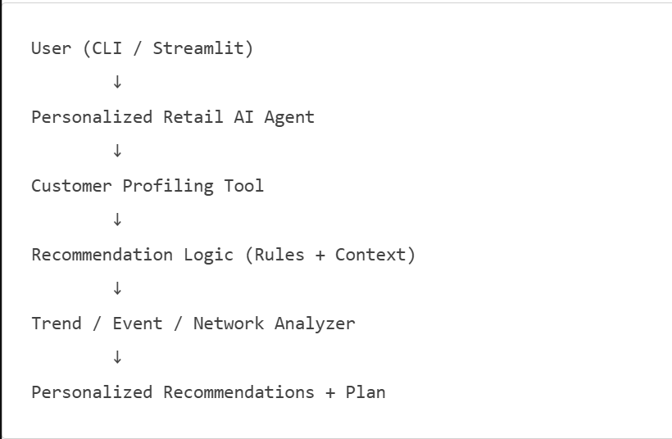

5. Functional Requirements

5.1 Individual Shopper Profiling (5–10 Parameters)
The AI Agent must build a shopper profile using the following sample parameters:
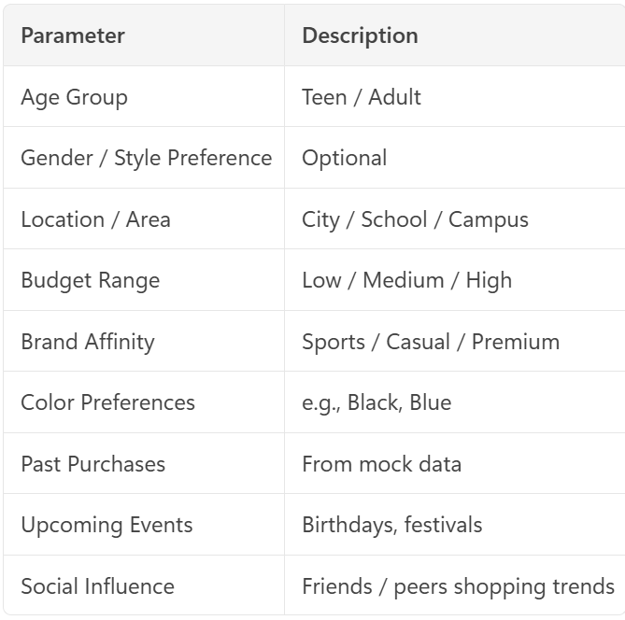
Social Influence | Friends / peers shopping trends
Profile may be inferred from mock questionnaire or dataset.

5.2 Highest Selling Design / Color (Area / School)
Requirement
The agent must be able to answer:
“What is the highest selling design / color in my area or school?”
Implementation Approach
- Use a local sales dataset grouped by:
  - Area / School
  - Product category
  - Color / design
- Agent calls a trend analysis tool
Output Example
“In your school area, blue hoodies have been the top-selling item this season.”

5.3 Social / Network-Based Recommendations
Requirement
The agent should consider:
- What friends / peers are buying
- Similar profiles’ purchase patterns
Implemented using:
- Mock “connections” dataset
- Similarity matching rules
Example
“Students in your network recently purchased oversized sweatshirts.”

5.4 Event & Occasion-Aware Recommendations
Requirement
The agent must check for:
- Upcoming festivals (Diwali, Christmas)
- Birthdays
- School events
- Seasonal sales
Events provided through:
- Static calendar JSON
Example
“Since Diwali is in 2 weeks, ethnic wear in your preferred colors is trending.”

5.5 Personalized Product Recommendation Engine
The agent must recommend:
- 3–5 products per interaction
- With clear reasoning
Each recommendation must consider:
- Profile fit
- Popularity
- Occasion relevance
- Budget alignment

5.6 Purchase Planning (Next 2–3 Purchases)
Requirement
The agent should proactively suggest:
- Next likely purchases
- Logical shopping sequence
Example
“After this purchase, you may need matching footwear and accessories.”
This demonstrates agent foresight and planning.

5.7 Comparative Recommendations (Fashion / Price / Brand)
Requirement
For a given product, the agent should provide:
- 2–3 alternatives
- Comparison across:
  - Style
  - Price range
  - Brand value
Data from synthetic product catalog.

6. AI Agent Responsibilities
The AI Agent must:
- Build shopper profile
- Analyze local trends
- Consider social influence
- Adjust for upcoming events
- Generate recommendations
- Explain why each product fits
- Plan future purchases
- Provide comparisons
- Stay within ethical retail guidance

7. Output Requirements
Each response must include:
- Profile Summary
- Local / Peer Insights
- Recommended Products
- Personalized Reasoning
- Next Purchase Plan
- Comparative Suggestions
- Disclaimer
Sample Output
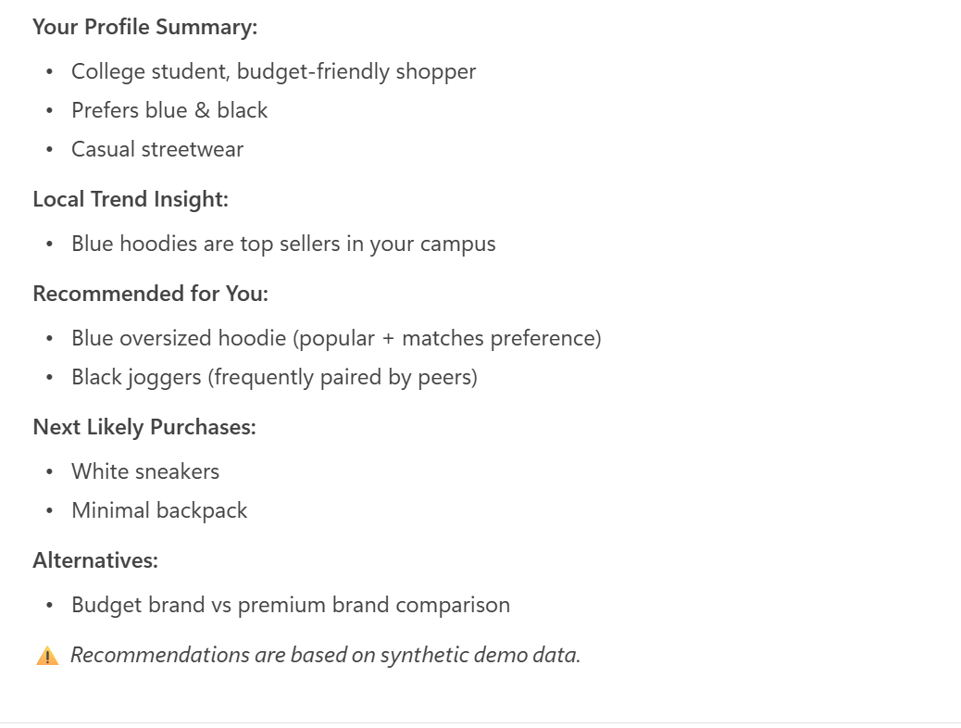

8. Non-Functional Requirements
- Runs offline
- Uses Ollama LLM
- Easy to understand outputs
- Handles missing data
- Response time < 5 seconds

9. Technology Stack
Mandatory
- Ollama (e.g., llama3)
- Python
- CSV / JSON datasets:
  - Users
  - Products
  - Trends
  - Events
  - Social connections
Optional
- Streamlit UI
- LangChain (tool calling)

10. AI Agent Design Guidelines
Must Demonstrate
Contextual reasoning
Personalization logic
Multi-factor decision making
Explainability
Business value articulation

11. Ethics & Safety
The agent must:
- Avoid manipulation
- Avoid discriminatory profiling
- Avoid guaranteed savings claims
- Clearly label recommendations as suggestions

12. Mock Dataset Requirements
Synthetic datasets only:
- Products (category, style, color, price)
- Sales trends by area/school
- User profiles
- Social networks
- Event calendar

